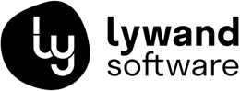
Insert logo here

Your Automated IT Security Analysis with lywand

More Transparency. Less Risk.
Going forward, we rely on lywand to regularly and automatically review our customers’ IT security. This allows us to identify potential vulnerabilities early and ensure that your company remains protected in the long term.

Your Benefits at a Glance
- Automated security checks: Regular scans of your systems and networks for vulnerabilities.
- Full transparency: Clear reports show you, in an easy-to-understand way, where action is needed.
- Early risk detection: Issues are identified before they lead to security incidents.
- Prioritized recommendations: We know exactly which measures should be implemented first.
- Proactive support: We take care of evaluation, implementation, and ongoing optimization.

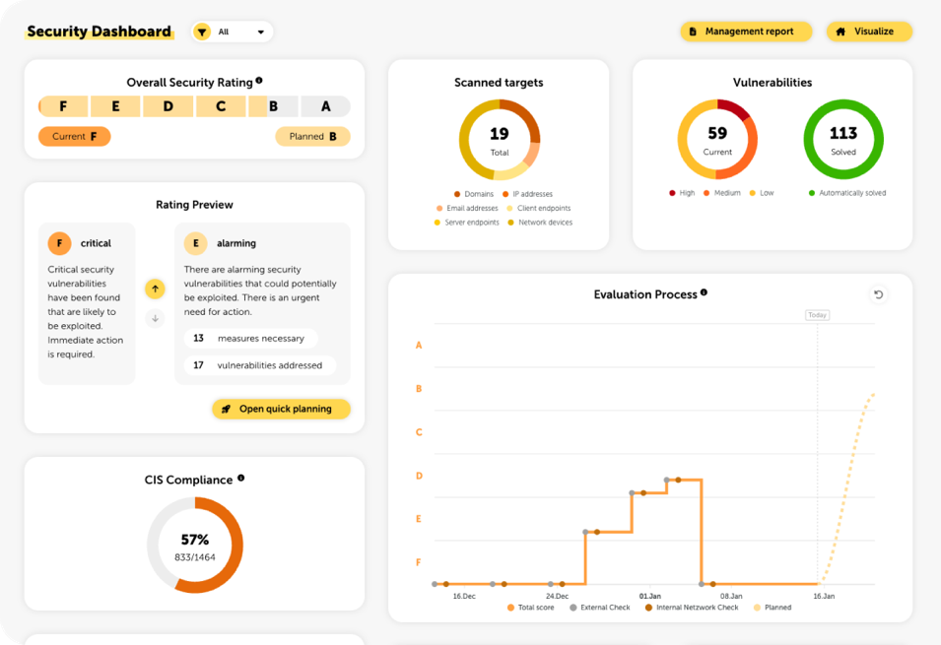
Why lywand with Company?
- Continuous security analysis instead of one-time assessments
- Clear, easy-to-understand reports for decision-makers
- Personal contact and active implementation by our team
- Higher security without additional effort on your part

Company
📧 Email
Phone
🌐 Website
Questions or Interested?
If you have any questions or are interested, feel free to contact us directly. We will be happy to advise you personally and show you how we can improve your company’s IT security with lywand.

